|  |  |
| --- | --- |
| bird box  A 3D Survival Post-apocalyptic game | AbOUT  This game is about a woman’s survival in a town looking for refuge when the earth is attacked by an unknown invisible entity that possesses human the moment they see the entity, causing the person to kill himself.  NOOR UL AIN  BSCGD-3A  231758 |

# Table of Contents

Table of Contents 1

1. Game Concept 5

1.1. High Concept Statement 5

1.2. Player’s role 5

1.3. Primary Gameplay Mode 5

1.4. Target Audience 5

1.5. Competition Modes 5

1.6. Progression 5

1.7. Game World 5

1.8. Genre 6

1.9. Setting 6

1.10. Key Characters 6

2. Game world 6

2.1. Physical Dimension 6

2.1.1. Spatial Dimensionality 6

2.1.2. Boundaries 6

2.2. Temporal Dimension 6

2.3. Environmental Dimension 6

2.3.1. Cultural Context 6

2.3.2. Physics Surrounding 6

2.3.3. Detail 6

2.3.4. Defining a Style 6

2.3.5. Sources of inspiration 7

2.4. Emotional Dimension: 7

2.5. Ethical Dimension: 7

3. Areas and Map 7

3.1. Areas 7

3.2. Map 7

3.3. Wireframes 8

4. Game controls 10

4.1. Gesture Controls 10

4.1.1. For PC 10

4.1.2. For PS4+ 10

4.2. Eye Cover Control 10

4.3. Quick Action Buttons 10

4.3.1. For PC 10

4.3.2. For PS4+ 10

4.4. Combat 10

4.4.1. For PC: 10

4.4.2. For ps4: 10

4.5. Audio Alert System 11

4.6. Map access 11

4.7. Health and Alert Display 11

4.8. Interact with NPCs or Side characters 11

5. Gameplay 11

5.1. Game objective: 11

5.2. Game Progression: 11

5.2.1. Initiation: 11

5.2.2. Progression: 12

5.2.3. Termination: 12

5.3. Play Flow 12

5.4. Mission/Challenge structure 12

5.5. Puzzle Structure 12

5.6. Physics: 13

6. Rules 13

6.1. Implicit rules 13

6.2. Explicit rules 13

7. Relationships of Entities, Processes, and Events 13

7.1. Entities and Their Relationships 13

7.1.1. Player: 13

7.1.2. Invisible Entity: 13

7.1.3. Birds in Cages: 14

7.1.4. Obstacles: 14

7.1.5. Powers: 14

7.2. Events 14

7.2.1. Triggering the Invisible Entity: 14

7.2.2. Finding a Bird: 14

7.2.3. Player’s Failure: 14

7.2.4. Gaining Powers: 14

7.3. Processes 14

7.3.1. Survival Mechanic: 14

7.3.2. Obstacle Navigation: 14

7.3.3. Game Progression: 15

8. Internal Economy 15

8.1. Source 15

8.2. Drains 15

8.3. Converters 15

8.4. Traders 15

8.5. Production 15

9. Characters 16

9.1. Main character/s 16

9.1.1. Malorie Hayes 16

9.1.2. Tom “Boy” 16

9.1.3. Olivia “Girl’ 16

9.2. Side character/s 16

9.2.1. Jessica Hayes 16

9.2.2. Douglas, Greg, Cheryl, Felix, Charlie, and Lucy 16

9.3. Antagonist/s 16

9.3.1. Entity 16

9.3.2. Gary 16

9.3.3. The cult 16

9.4. NPCs 16

9.4.1. Blind-fold 16

9.4.2. Clues 16

9.4.3. Treasure 16

10. Resources, Entities and their Attributes 17

10.1. Resources 17

10.2. Entities and their Attributes 17

10.2.1. Bird 17

10.2.2. Player 17

10.2.3. Enemy 17

10.2.4. Safe Ring 17

10.2.5. Levels Progression 17

10.2.6. Side Character 17

10.3. Links 18

12. Levels 18

12.1. Level 1: 18

12.2. Level 2: 18

12.3. Level 3+ 19

12.4. Hierarchy 20

13. Interface: 20

13.1. Visual system: 20

13.1.1. HUD 20

13.1.2. Shell Menus 20

Restart Level: 21

Accomplishments: 23

Change profile: 24

Settings button: 24

Volume button: 25

13.1.3. Camera Model 25

13.2. Audio, Music, Sound Effects 25

13.3. Game Art 25

13.4. Disabled players 25

13.5. Help System 25

14. References 26

Bird-Box

# Game Concept

## High Concept Statement

In this game, “Bird Box”, the story starts as a town is under attack of an invisible entity that eliminates them if the player doesn’t cover their eyes in time. Player can only survive if they find specific number of birds hidden in multiple places in town e.g. police station, school, house, etc. that are yet to be found. The player crosses the hurdles and puzzles in time limit only without the presence of entity. With time, entity visits more often too. With the progression of game, the player can also get slight powers in protecting himself from entity as a save ring, or another try.

## Player’s role

Player’s role is to save the herself from invisible entity by collecting and finding specific number of birds and mainly, finding a refugee.

## Primary Gameplay Mode

In primary gameplay position, the player can enjoy the cutscene as they are shown some backstory needed for continuation in story together with gameplay. Player also learns some basic controls required to learn for the game instead of a tutorial.

## Target Audience

Since, it is not difficult to play or understand the gameplay, also it will be more fun for young teens therefore it will be more appropriate for age range of 11-16.

## Competition Modes

To find birds in a cage hidden in different places crossing each obstacle.

## Progression

Level-by-level game progresses as the player completes one level after finding one bird at one place. Bird cage is found by multiple different obstacles in each level with progression of storyline.

## Game World

3D game with a dark aesthetic using sound priority.

## Genre

Horror, adventure, exploring, open-world.

## Setting

In first-half, game is set in a town with broken buildings, car accidents, etc. some parts in first-half are also in new locations like house, supermarket etc. In second-half, game is set in a dark forest looking for a refugee.

## Key Characters

Main character, Malorie, Invisible Entity, child (as game and story progresses, new characters unlock adding more to story).

# Game world

## Physical Dimension

### Spatial Dimensionality

It is a 3D game using time in some tasks but each level has one specific time of day which doesn’t changes unless next level or next phase.

### Boundaries

It is an open-world game free for player to explore and access resources or interact with NPCs within limits of environment.

## Temporal Dimension

Time in this game is as each level has a specific time of day that doesn’t changes until next level or next phase.

## Environmental Dimension

### Cultural Context

Game is set in modern period of time but when the entity attacks, a chaos is created in ending more than half the population.

### Physics Surrounding

The woman is in an abandoned town, initially, where people are rare to be found.

### Detail

The game features a dark and suspenseful aesthetic, with shadowed streets, dim lighting, and ominous skies, broken buildings, car accidents, blood and dark themes like dead bodies where digital communication is also cut.

### Defining a Style

The manual like UI and shell menus or main gameplay use dark greyish-black and dark blue colors with dark shadowy adjustments. The character, whereas, looks muddy and dis-shelved hairs in a ponytail in easy-to-move-in clothes with a heavy backpack to keep essentials needed and to keep the resources as they are discovered.

### Sources of inspiration

Survival and post-apocalyptic theme.

## Emotional Dimension:

This game expects the user to have emotions like, curiosity (to see the end), tricky (solving puzzles), player involvement (during choices), emotional (when player’s sister dies or when thee children require pep talk), thrill (during hurdles or fights), anxiety (during entity presence).

## Ethical Dimension:

Players must decide when to look away or confront, testing their survival instincts. Players may find clues or warnings left by other survivors, choosing whether to follow them or take a riskier path. Each face-off impacts future gameplay, with the character’s mental resilience affected by each escape or failure.

# Areas and Map

## Areas

The game revolves in Michigan and the places in it like the station, supermarket, school etc., named as said, and the forest is the nearby forest around.

## Map

The map shows area inn Michigan. Forest on side, with a lake where an abandoned cabin is near lake. The town has school, children’s park, supermarket, mall, store, etc. a rough wireframe for a map can be shown as:

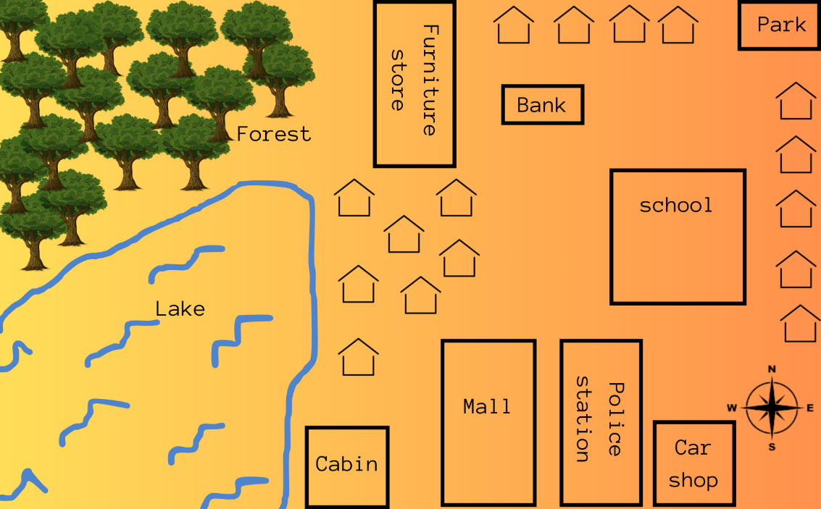

## Wireframes

When game is opened:

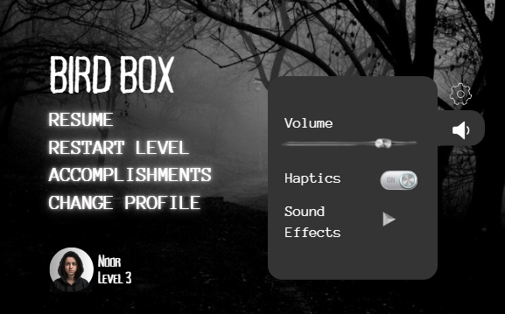

Gameplay:

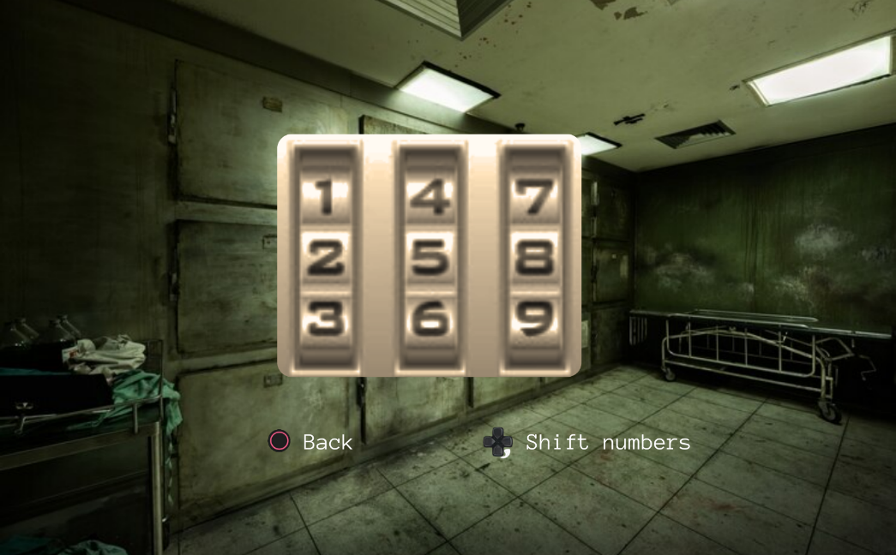

When gameplay paused:

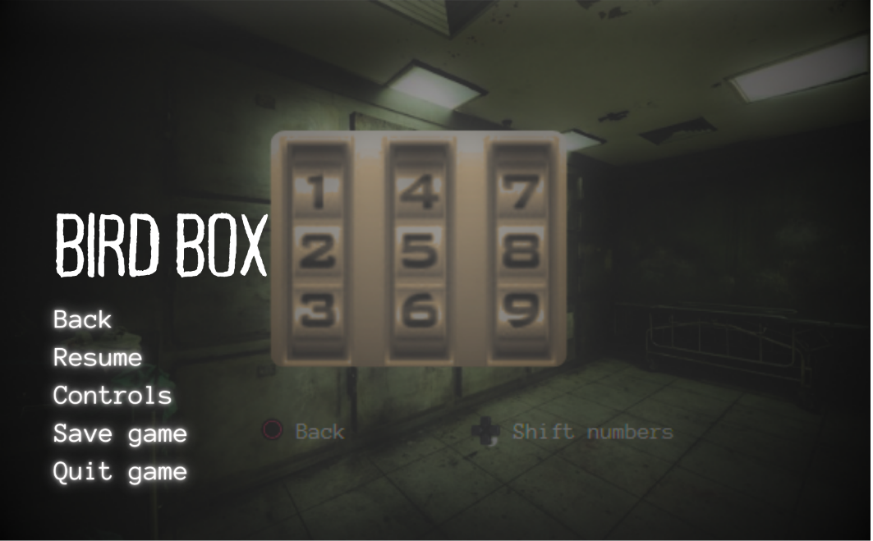

# Game controls

## Gesture Controls

### For PC

Arrow Keys Up: Walk through.

WASD: Walk through.

Mouse: to change view angle.

V: Focus to examine or look deeper.

### For PS4+

L console: to walk around.

R console: To change angle view.

R1: to focus to examine or look deeper.

⭘: to select

X: to go back

## Eye Cover Control

Spacebar (Keyboard): Cover eyes to hide from the entity and avoid detection.

L1 (PS4+): Same function as keyboard, covering eyes while looking down.

## Quick Action Buttons

### For PC

1-4 Number Keys: Access powers like Save Ring, gun, knife etc.

Hold Shift + Number Key: Inventory that views elements in backpack like food, medicine etc.

G: to use the element you chose from bag.

### For PS4+

Arrow buttons: for accessing powers like safe ring, gun, knife etc.

Pressing on Keypad: for inventory.

L1 and R1: to shift in items.

Hold R2: to use the element you chose.

## Combat

### For PC:

X: to attack from knife or fight.

Mouse right click: to aim

Mouse left click: to shoot.

### For ps4:

🞏: To attack with knife or fight

L2: Aim from.

R2: To shoot.

## Audio Alert System

Use Headphones or Speaker Alerts: Player hears whispers or footsteps to signal entity proximity, needing quick response to avoid detection.

## Map access

Q (PC): View map of the town to see areas already discovered or to be discovered areas, for navigation.

Swipe-board(PS4+): View map of the town to see areas already discovered or to be discovered areas, for navigation.

## Health and Alert Display

During combat: Visual and sounds show themselves how much the player is hurt from how grey or bloody the screen is.

For PS4+, Hold “R2”: Displays Health Meter in the corner, changing from green (safe) to red (danger), alerting the player to entity proximity.

For PC, Hold “Q”: Displays Health Meter in the corner, changing from green (safe) to red (danger), alerting the player to entity proximity.

## Interact with NPCs or Side characters

For PS4+, “ $∆$” to interact.

For PC, “F” to interact.

# Gameplay

## Game objective:

Main objective of the game is to cross hurdles and explore places to find a way to save herself(player) from the invisible entity which can be only be through birds.

## Game Progression:

### Initiation:

Initially, the player is shown some cut scenes where a new world is explained about how, when and events that happened with the main character that is, Malorie. This teaches basic functioning needed for player to learn. Cut-scene is as follows,

A news broadcast reports unexplained mass suicides spreading across Europe and Asia. After an outing, Malorie witnesses a woman smashing her head repeatedly into the window. Others start acting suicidal as well, causing panic and chaos. Malorie and Jessica leave hurriedly. Driving away from there (Jessica is driving with navigations given teaching basic controls to basic player), Jessica sees something inexplicable which drives her insane so she deliberately crashes the car. She then intentionally walks in front of a speeding truck. Player then enters level 1 where Malorie (player) runs to find a safe place with some other side characters.

### Progression:

The game progresses with the storyline, as the player protects himself from the invisible entity, finding clues, solving puzzles that will help him find bird cages that will later help in ending the entity or at least protecting him from entity to finding a refuge.

### Termination:

* + - 1. In case of low energy or health, the player slows down with hard breathing.
      2. In case of not covering eyes in time, the player gets hurt (haptics/sound/visuals) until he covers the eyes. In case of still not covering, the player dies and restarts with the last checkpoint.
      3. In case of losing in a fight, the player restarts from the last checkpoint.

## Play Flow

The player will explore the town, gather resources, solve clues, find bird cages and find a safe refuge. Player will also engage in combat with monsters and aliens, using a variety of weapon or safe ring if available. The player may encounter other survivors (side characters) during their journey, that will help the player by guiding them.

## Mission/Challenge structure

Challenge will be when the player has to solve puzzles or cross hurdles in given time (in some cases). This requires IQ and quick reflexes for a player.

## Puzzle Structure

Many types of puzzles will be created at an appropriate place where required. For example,

* Puzzle lock (to unlock a lock requires clues around the room)
* Jigsaw Puzzle (to sort an image that will give some hint or backstory of entity)
* Completing word Riddle (regarding the past information player already knows)
* Question Option Riddle (answered by some information scattered around room)
* Keypad Lock (solved by looking for clues around)
* Etc.

## Physics:

Physics in this game is used to make player experience realistic by involving gravity concepts, like when an element is thrown, etc. similarly, to lower the speed of player when low on energy and health and when hurt, also involves physics.

# Rules

## Implicit rules

* + 1. Players must balance exploration with caution to avoid the entity.
    2. Hiding is essential; failure to hide in time results in being caught by the entity.
    3. Players must rely on audio cues to determine when the entity is nearby.
    4. Moving recklessly increases the chance of encountering the entity.
    5. Observing surroundings is vital for finding birds and navigating obstacles.

## Explicit rules

* + 1. Each level has a specific objective to pass before progressing to the next.
    2. Players must press the designated button/key (e.g., **F**) to cover their eyes when the entity appears.
    3. Failing to hide on time results in death and a restart of the level.
    4. Some levels have a set time limit to collect the birds and escape.
    5. Safe Ring can be used once per level to protect against the entity.
    6. Inventory is limited. Player must manage resources carefully.
    7. The entity’s appearance becomes more frequent with time and progression.
    8. The entity will only retreat if the player successfully hides or cover eyes until it is gone.
    9. Players must solve puzzles or overcome physical barriers to reach certain bird cages.

# **Relationships of Entities, Processes, and Events**

## **Entities and Their Relationships**

### **Player**:

The player's survival depends on covering their eyes in time to avoid the invisible entity, collecting birds in cages to progress and utilizing limited powers (e.g., save ring, retries).

### **Invisible Entity**:

The entity becomes more frequent as the game progresses. It triggers the need for the player to hide their eyes when nearby.

### **Birds in Cages**:

**The cages** act as the goal for each level. The player's success depends on finding all required birds in a level or the main objective supporting the storyline.

### **Obstacles**:

They block the player’s path to the birds. They increase in difficulty as levels progress.

### **Powers**:

They help the player survive when caught by the entity that are collected or earned through birds.

## **Events**

### **Triggering the Invisible Entity**:

Condition: The player moves within proximity of the entity.

Event: The player receives an audio cue. They must cover their eyes by pressing a key.

### **Finding a Bird**:

Condition: The player navigates obstacles and interacts with a hidden cage.

Event: A bird is collected, progressing the level.

### **Player’s Failure**:

Condition: The player fails to cover their eyes in time or falls into an obstacle.

Event: The player health decreases. If the health dies, playerretries the level.

### **Gaining Powers**:

Condition: Completing specific tasks or challenges.

Event: The player gains a power like a safe ring.

## **Processes**

### **Survival Mechanic**:

Initiation: The entity is nearby.

Sequence:

1. The player hears a sound.
2. The player hides their eyes.
3. The entity moves away or catches the player if not hidden in time.

### **Obstacle Navigation**:

Initiation: The player starts the level.

Sequence:

1. The player encounters various challenges.
2. The player overcomes them using strategy and timing.
3. The player reaches the bird’s location.

### **Game Progression**:

Initiation: The player collects the required bird(s) in a level.

Sequence:

1. The game unlocks the next level with increased difficulty.
2. New characters, abilities or new obstacle are introduced progressing the storyline.

# **Internal Economy**

## **Source**

**Bird Cages**: They are achieved after some puzzle or hurdle.

**Health:** A player has some health on which it survives on.

## **Drains**

**Player’s Survival**: Power is decreased as the safe ring or power is used.

**Health: Health is lost and lowers when there is damage to player like in fighting or an interaction with entity.**

## **Converters**

**Bird Cages:** They give some type of clue or origin supporting the storyline, or they give some power like safe ring.

**Health:** The more health there is (until full), the more the stronger effect in fight or combat.

## **Traders**

**Bird cages**: Birds can be traded for or sacrificed in return of food in case player is unable to find any food around.

## **Production**

**Bird Cages**: They are scattered across the map, hidden in locations like schools, houses, and police stations

# Characters

## Main character/s

### Malorie Hayes

She is the main character that player plays the role of. She is atheletic and determined to find a way out .

### Tom “Boy”

The child player stumbles upon in a school.

### Olivia “Girl’

The child she stumbles on in a street when she saves the child but fails to save her mother which made the player to take the girl with her.

## Side character/s

### Jessica Hayes

She is sister of main character, Malorie’s sister.

### Douglas, Greg, Cheryl, Felix, Charlie, and Lucy

The people she has to live with for some time initially in a random but secure house.

## Antagonist/s

### Entity

It is the invisible entity (indicated as a wind with rusty leaves) that makes people to kill themselves thorough eye contact.

### Gary

The hypocrite guy in the group who had some link with the entity, forcing the other members of the house to go out so they kill themselves.

### The cult

A cult of different beliefs asking Malorie to join them in jungle/forest. Due to their weird energy and beliefs and sheepish looks, due to which they end up having an argument that turns into a fight.

## NPCs

### Blind-fold

A random piece of cloth cut from a curtain to cover her eyes.

### Clues

Found when area explored that will help player later.

### Treasure

Useful items found randomly or help to figure out the entity and know more about it’s origin, weaknesses etc.

# Resources, Entities and their Attributes

## Resources

|  |  |
| --- | --- |
| Resources | Description |
| Weapon | A rusty knife for survival, gun/pistol when found. |
| Food | Any food she finds (edible) |
| Blindfold | To cover the eyes |
| Backpack | To keep the essentials like food, map, medicine etc. |
| Map | Navigate through unexplored areas |
| Ammunition | Required for gun |

## Entities and their Attributes

### Bird

* Hidden spot (where the bird is hidden)
* Hidden power (each bird has a different power)
* Type (type of bird, color, shape, size etc.)

### Player

* Health (depending on food eaten time to time)
* Armour (saving from cold, or kneecaps etc.)
* Level (levels discovered or completed)
* Position (position in gameplay axis)
* Status (the current status of player)

### Enemy

* Health (how strong enemy is)
* Detection (the radius through which the player could be detected)
* Sound and Wind Effects (when the entity makes its presence known)

### Safe Ring

* Duration (how long the effect will be)
* Effect (each ring has different powers or protection from a specific thing)
* Cooldown (The blinking time when its duration is almost finished)

### Levels Progression

* Birds unlocked
* Riddles solved
* Next level / storyline/ cutscenes (showed and to be shown)

### Side Character

* Movement (in gamwplay axis)
* Role (in helping or guiding the player)

## Links

* + 1. A bird is discovered by the player when its time comes
    2. A bird has a power or a safe ring granting to player to protect themself.
    3. Enemy attacks on player frequently.
    4. Side character helps or guides the storyline.
    5. Levels progress with player’s progress.
    6. Levels progress with side character’s role in storyline.
    7. Safe ring protects player.

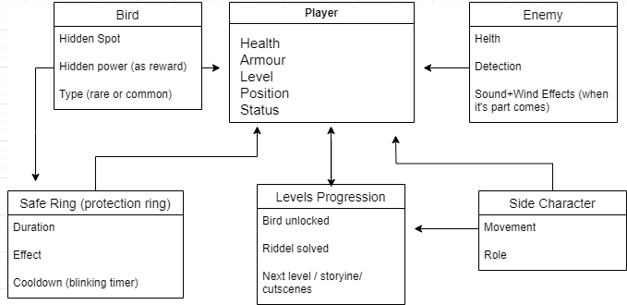

# Levels

## Level 1:

In level 1, the woman finds a way out the busy street of people running to get in a safe house where she discovers that the entity possesses the people through eyes. In this level, basic controls are taught and the woman also stumbles upon a knife keeping for herself. The level is completed when she finds a secure random house locking the door and letting some more people requiring refugee (people that are not possessed).

## Level 2:

In level 2, the woman thinks she is safe as all the window are now painted black, and soundproof. She and some other people in house conduct an experiment if the entity can be seen or possess people even through the screen via cctv cameras where one member sacrifices for the experiment for the test (chosen by player’s choice). Using cut scenes and haptics, the crew finds it that it is possible and the member who volunteered ended up killing himself. In this level, they also find out they are out of food and decide to go to a nearby supermarket. This level exposes the player to an outer world teaching the use of blindfold. The woman explores the new area that is super market, taking essentials in the inventory, putting in her bag, like food, medicine, map.

## Level 3+

In the next levels, the player starts to explore some new lands with her crew in the town looking for help or refugee e.g. school, police station, hospitals. In these levels, story also continues with some inner conflicts between crew causing them to split. Some conflicts also occur when an antagonist arrives. Player also gets some birds for herself together with rescuing two kids, Tom and Olivia. She ends up leaving for the forest with the children where she faces some hurdles and obstacles along with a fight with a cult and finds a tree house doing basic survival tricks to live as long as possible keeping herself and the children safe, while still looking for a refugee. In the end, she finally has enough birds and enough powers to find a refugee using IQ and brain solve the riddle through radio and map to navigate throught the location requiring more exploration until she does.

## Hierarchy

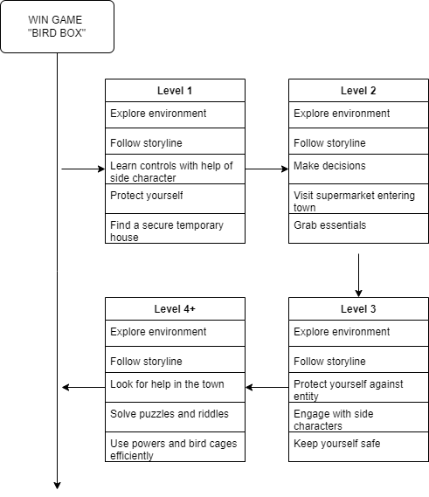­­­­­

# Interface:

## Visual system:

### HUD

Generally, there is no head ups display so that the screen is clear and open for player to look around. By clicking on certain buttons (as explained in controls already), the head ups like, health meter is shown. During puzzle solving, timer is shown in a corner too.

### Shell Menus

On main menu, when clicked on resume:



Restart Level:

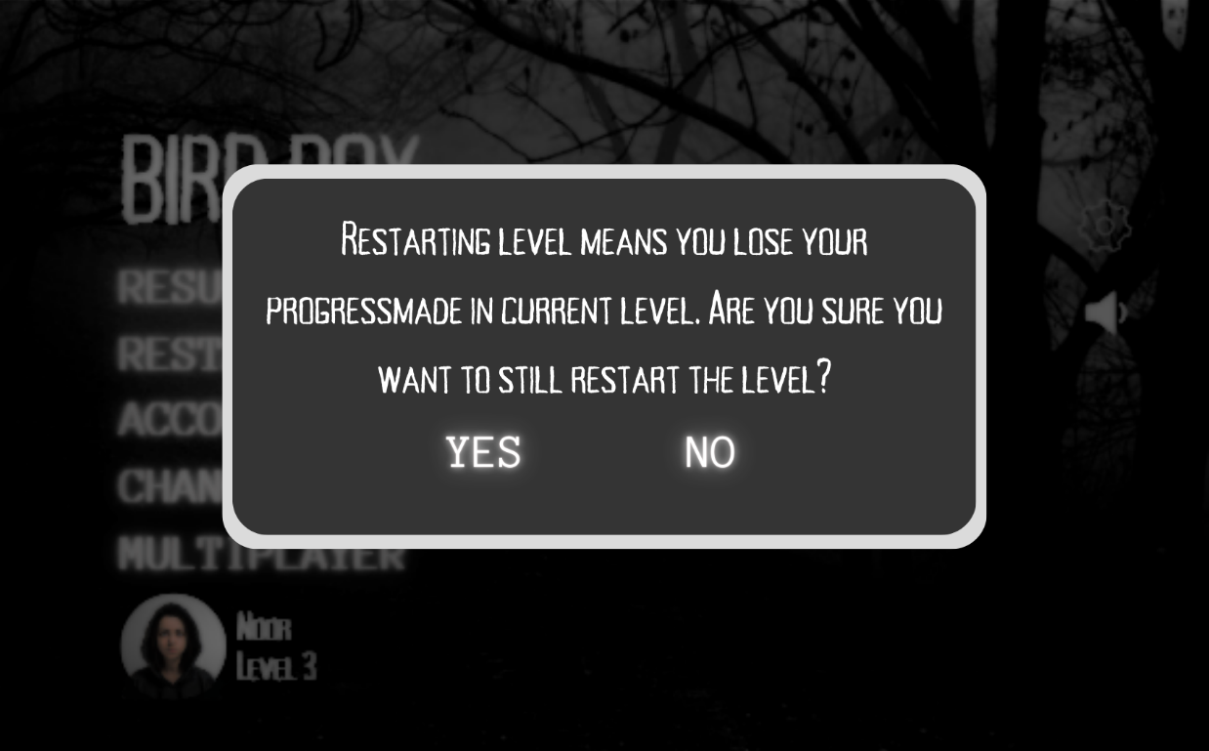

*If yes:*



*If no:*



Accomplishments:

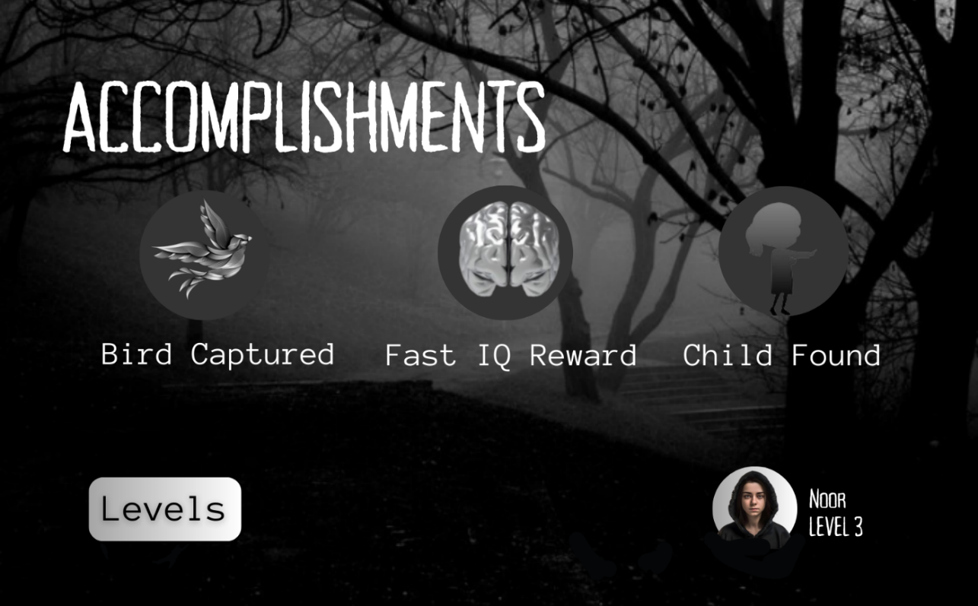

*If clicked on levels:* 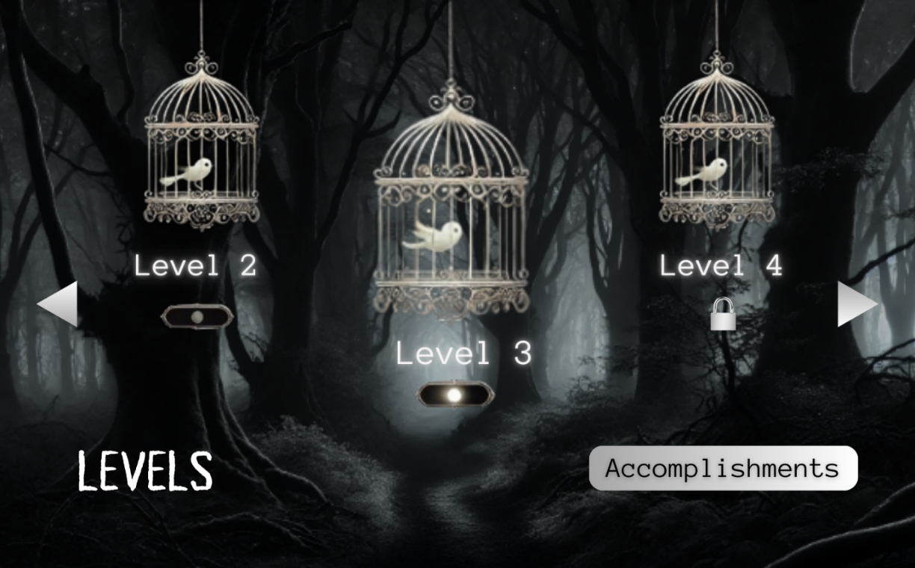

Change profile:

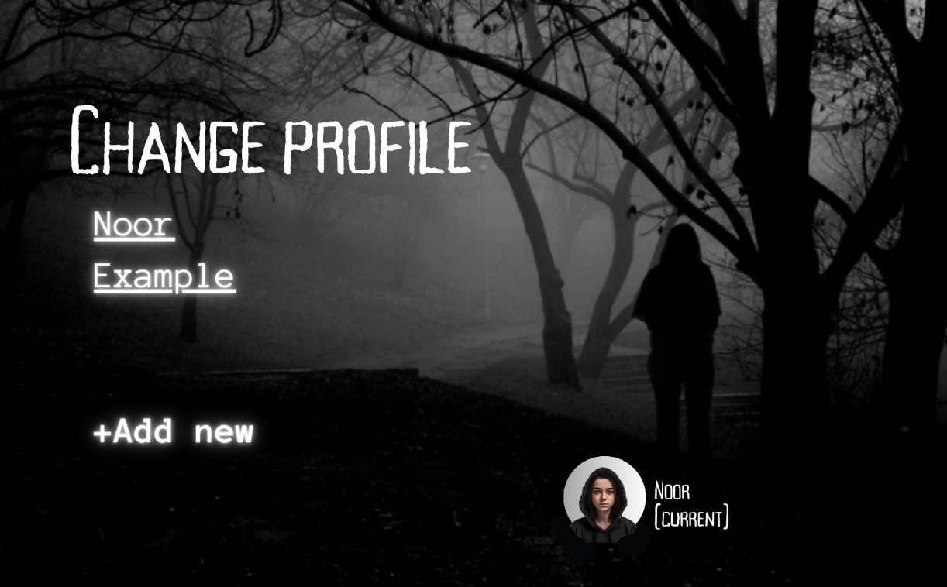

Settings button:

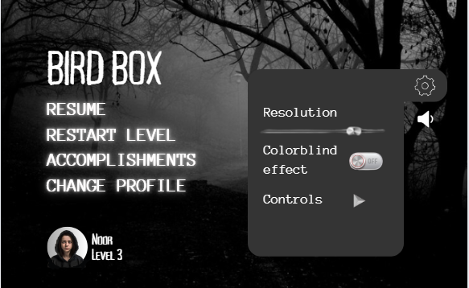

Volume button:

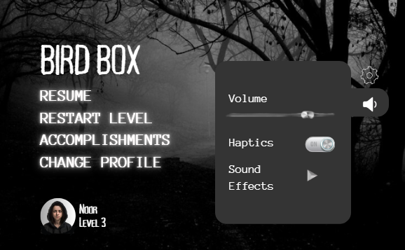

### Camera Model

Third-person over-the-shoulder view for better situational awareness. Slight zoom-in when hiding or interacting with objects to increase tension. Dynamic camera movements during cutscenes and entity encounters to emphasize horror.

## Audio, Music, Sound Effects

Haptics (in controllers), dark music, sound effects like, breathing hard, fighting sounds (when fighting or punching or shooting) make the user experience great.

## Game Art

3D realistic looking art style with high resolution and graphics for a better user experience.

## Disabled players

Colorblind option is available in settings. Resolution can be set as player sees fit.

## Help System

The game can be helped when struggling in the game. During gameplay, the player can pause the gameplay to make changings in controls or mechanics or other important aspects of game. Similarly, settings could be changed from default from home page. The game will also have in-game tutorial in form of a beginner first level to help the player learn the basic gameplay mechanics as they progress through the game. In case of difficulty in solving puzzles or hurdles in the game later during the gameplay, there could be a side character guiding them. Still, if the player is having problem understanding the hurdle, after some time span (i.e. 5 min) they could be given a hint.

# References

* 1. For drawing wireframes and shell menus, <https://www.canva.com/>.
  2. Inspiration from, <https://www.netflix.com/pk/title/80196789?source=35>.
  3. Inspiration from, <https://www.playstation.com/en-us/games/uncharted-4-a-thiefs-end/>.

All wireframes and shell menus shown except the image in cover page (made by ai) in this document are made using Canva by borrowing some assets like background etc. from google.